COHORT ANALYSIS REPORT WITH VISUAL INSIGHTS
Week 2 Deliverable (Team 9)
RIT Opportunity-Wise Student Participation & Engagement Analysis

Project metadata | Details
Deliverable title | Cohort Analysis Report with Visual Insights
Dataset | RIT_WEEK2_CLEANED_DATASET
Primary Worksheet | Week2 Cleaned Data 8,558 rows × 36 columns (16 original + 20 derived)
Date coverage | Apply Date: 5 Oct 2022 to 10 Apr 2024. Learner Signup Date: 5 Jan 2023 to 9 Apr 2024
Unit of analysis | Application records, not unique learners (the dataset has no learner ID)
Participation label | Participated = Started, Team Allocated or Rewards Award (see Section 2.3)

Contributors
Team members (name and email) | Contribution to Week 2 Deliverables
Ghufran Khan <iamghufrankhan1@gmail.com> | Feature Engineering, Data Preparation,  Finalizing Report
Victor Thompson <victor.thompsonva97@gmail.com> | Data Preparation, Feature Engineering
Khadija Kamal <khadijakamal6002@gmail.com> | Visualizations and Insights
Nour Ahmed <nourahmet77777@gmail.com> | Visualizations and Insights
Barira Khan <khanbarira47@gmail.com> | Trend and Category Analysis
Kamoru Olayemi Raji <Kamo4nice@gmail.com> | Visualizations and Insights
Oladosu Rophiat <olasubomi166@gmail.com> | Trend and Category Analysis

1. Executive Summary
This report analyses 8,558 application records from the RIT opportunity dataset across 23 opportunities in five categories. It documents the Week 2 data preparation, presents quarterly, category and cohort analysis, and identifies the signals most relevant to the Week 3 predictive models.
- Demand is concentrated in 2024 Q1. 2024 Q1 holds 4,785 applications (55.9% of the dataset), led by January 2024 (2,488) and February 2024 (1,913). January–February applications grew from 62 in 2023 to 4,401 in 2024. The only quarter-on-quarter decline is 2023 Q4 (applications −29.0%, signups −48.6%).
- Two distinct outcome pipelines. Course, Event, Competition and Engagement applications reach participation in 84.2% to 96.9% of cases. Internships reach it in 21.5%: 65.8% are rejected and 11.3% drop out. All 3,569 rejections and 613 of the 617 dropouts are internships; all 767 Started records are courses.
- Cohort participation fell from 75.6% to 29.5%. Between the 2023 Q1 and 2024 Q1 signup cohorts, participation fell 46.0 points. About 85% of that fall is explained by the shift of signups towards internships (25.0% of the 2023 Q1 cohort, 76.4% of the 2024 Q1 cohort); about 15% reflects lower rates within categories.
- Opportunity identity matters inside internships. Internship participation ranges from 11.4% (Digital Marketing) to 54.8% (Health Care Management). Four programmes carry the dropouts (20.3%–22.7%). Health Care Management allocated about 80% of its applicants until December 2023, then none of its 249 applications from February 2024.
- Timing and profile signals are weaker. 38.3% of applications arrive on the signup day and 25.5% arrive 90 or more days later; lag adds little on its own. Country, gender, age and weekend differences are small or mostly explained by category mix. Saint Louis University applicants (52.6% of records) participate less than others (41.3% vs 54.5%), including after standardising for internship opportunity mix.
- Forecasts and models are indicative only. Baseline forecasts miss by about 50% on average in backtests; the 2024 Q2 range of roughly 1,700 to 4,800 applications is a scenario, not a prediction. A baseline model reaches F1 0.767 on 2024 data, but almost all of it comes from separating internships from other categories (internship-only F1 0.069). Section 6 gives the details and cautions.
- Readiness. The dataset is ready for exploratory modelling under the conditions in Section 5: unit of analysis is the application record, outcome-derived fields must be excluded from predictors, 3,794 start dates remain blank, and evaluation should use a time-based split.

2. Data Preparation and Derived Features

2.1 Starting point
The Week 1 Cleaned_Data sheet (8,558 rows × 16 columns) was extended in Week 2 to 36 columns by the cleaning and feature-engineering steps below. No rows were deleted. A full-row check finds no exact duplicate records.

2.2 Cleaning steps performed this week
Table 1: Week 2 cleaning decisions
Item | Rows | Action | Reason
Gender: “Other” and “Don’t want to specify” | 18 | Merged into “Not Specified” | Both values carry no gender information; keeps groups usable
Institution Name blank | 4 | Filled with “Unspecified” | Optional free-text field; rows retained
Current/Intended Major blank | 5 | Filled with “Unspecified” | Optional field; rows retained
Opportunity Start Date blank | 3,794 | Left blank, not imputed | Blank for applications that never started; a made-up date would be false data. Four derived columns inherit these blanks
Application_Lead_Time_Days negative | 2,106 | Kept; flagged with Already_Started = 1 | Applied after the official start date; 1,878 of 2,106 are course records (Section 3.7)
Total rows | 8,558 | No rows deleted | All issues flagged rather than removed
Lead time (Start Date − Apply Date) is available for 4,764 records: 2,106 negative, 17 zero and 2,641 positive. The Week 1 data issues still flagged in the data (test accounts, possible duplicate pairs, implausible birth dates, inferred day/month correction) were not altered.

2.3 Derived features
Twenty features were derived. Quarter extraction uses the calendar quarter of the relevant date: year, then “Q”, then the month number divided by three and rounded up (for example, 14 June 2023 becomes 2023 Q2). Signup_* features come from Learner Signup Date and define cohorts; Application_* features come from Apply Date and define application trends. The two are kept separate throughout this report.
Table 2: Feature engineering summary
Feature | Derived from | Logic | Analytical purpose
Signup_Year | Learner Signup Date | Year of signup | Compare signup activity across years
Signup_Month / Signup_Month_Name | Learner Signup Date | Month number and name | Monthly signup patterns and readable charts
Signup_Quarter | Learner Signup Date | Year & “ Q” & ROUNDUP(month/3) | Defines signup cohorts by quarter
Signup_Weekday / Signup_Weekend | Learner Signup Date | Day name; 1 if Saturday or Sunday | Weekday versus weekend signup behaviour
Application_Year | Apply Date | Year of application | Compare application activity across years
Application_Month / _Month_Name | Apply Date | Month number and name | Monthly application trends
Application_Quarter | Apply Date | Year & “ Q” & ROUNDUP(month/3) | Quarterly demand and trend analysis
Application_Weekday / _Weekend | Apply Date | Day name; 1 if Saturday or Sunday | Which days learners apply
Signup_To_Application_Days | Apply Date, Signup Date | Apply Date − Signup Date | Speed of conversion from signup to application
Application_Lead_Time_Days | Opportunity Start Date, Apply Date | Start Date − Apply Date | How far ahead of (or after) the start a learner applies
Already_Started | Application_Lead_Time_Days | 1 if lead time < 0, else 0; blank if no start date | Flags applications made after the official start
Signup_To_Opportunity_Start_Days | Opportunity Start Date, Signup Date | Start Date − Signup Date | Time between signup and opportunity start
Opportunity_Duration_Days | Opportunity End Date, Start Date | End Date − Start Date | Scheduled length of an opportunity
Age_at_Signup | Date of Birth, Learner Signup Date | Completed years between the two dates | Age-related participation patterns
Age_Group | Age_at_Signup | Under 18; 18–24; 25–34; 35+ | Demographic comparison bands
Participated | Status Description | Started, Team Allocated, Rewards Award → Participated; Rejected, Dropped Out, Withdraw → Not Participated; Waitlisted, Applied → Applied | Working participation label for analysis and Week 3 target definition
Participated label counts: Participated 4,072 (47.6%), Not Participated 4,272 (49.9%), Applied 214 (2.5%). The label groups statuses for analysis; it is not a verified completion measure.

3. Exploratory Data Analysis

3.1 Quarterly trend analysis
Table 3: Application and signup volume by quarter
Quarter | Applications | % of total | QoQ change | Signups | % of total
2022 Q4* | 43 | 0.5% | – | – | –
2023 Q1 | 178 | 2.1% | – | 504 | 5.9%
2023 Q2 | 602 | 7.0% | +238.2% | 1,442 | 16.8%
2023 Q3 | 1,716 | 20.1% | +185.0% | 2,539 | 29.7%
2023 Q4 | 1,218 | 14.2% | −29.0% | 1,306 | 15.3%
2024 Q1 | 4,785 | 55.9% | +292.9% | 2,755 | 32.2%
2024 Q2* | 16 | 0.2% | – | 12 | 0.1%
Total | 8,558 | 100% |  | 8,558 | 100%
* 2022 Q4 holds apply-before-signup dates; 2024 Q2 is partial (data end 10 April 2024). QoQ change is shown only between complete, valid quarters.
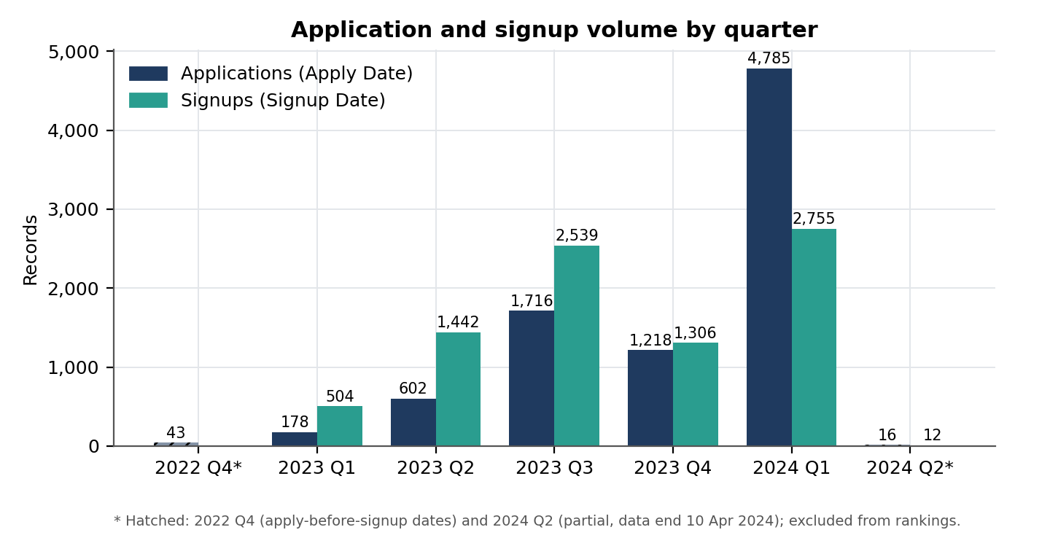
Figure 1: Application and signup volume by quarter.
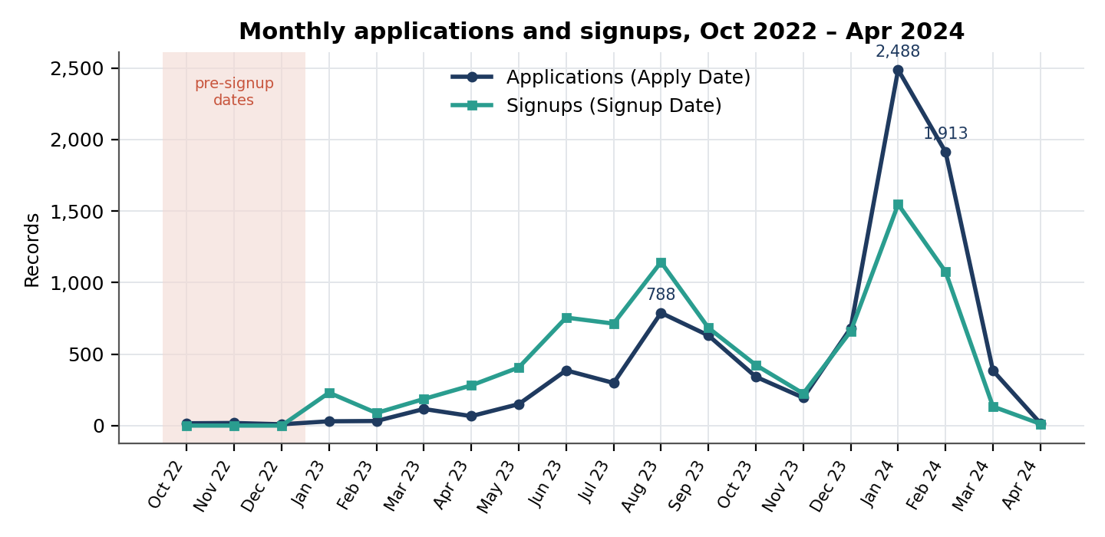
Figure 2: Monthly applications and signups. The shaded months hold apply dates earlier than the first signup (5 Jan 2023).
- Highest period: 2024 Q1 with 4,785 applications (55.9%). Of these, 3,472 (72.6%) are internship applications. Among signups the peak quarter is also 2024 Q1 (2,755, 32.2%), followed by 2023 Q3 (2,539, 29.7%).
- Lowest valid period: 2023 Q1 with 178 applications (2.1%). The lowest valid months are January 2023 (30), February 2023 (32) and April 2023 (66). The 2022 months (October 16, November 18, December 9) and April 2024 (16) are excluded as pre-signup dates or a partial month.
- Growth: Applications rose from 178 in 2023 Q1 to 4,785 in 2024 Q1 (26.9×); the quarter-on-quarter changes were +238.2%, +185.0%, −29.0% and +292.9% (Table 3). Comparing the same months, January–February applications grew from 62 (2023) to 4,401 (2024).
- Only decline: 2023 Q4. Applications fell 29.0% and signups fell 48.6% against 2023 Q3; December 2023 then recovered to 682 applications.
- Applications versus signups: 2024 Q1 holds 55.9% of applications but 32.2% of signups because 2,028 of its applications (42.4%) came from learners who signed up in earlier quarters.
- Consistency across years: Only Q1 appears in both years, so year-on-year comparison is possible for that quarter alone: 2024 Q1 is 26.9 times the 2023 Q1 level. The dataset holds one full year (2023), so repeating seasonal patterns cannot be confirmed statistically.

3.2 Opportunity category analysis
Table 4: Category volume, participation rate and status mix (% of each category’s applications)
Category | Apps | % of vol. | Part. rate | Started | Team Alloc. | Rewards | Waitlisted | Applied | Withdraw | Dropped Out | Rejected
Internship | 5,421 | 63.3% | 21.5% | 0.0% | 21.5% | 0.0% | 0.0% | 0.3% | 1.1% | 11.3% | 65.8%
Course | 2,037 | 23.8% | 93.2% | 37.7% | 54.7% | 0.8% | 5.4% | 0.3% | 1.2% | 0.0% | 0.0%
Event | 545 | 6.4% | 96.3% | 0.0% | 94.1% | 2.2% | 0.0% | 3.3% | 0.4% | 0.0% | 0.0%
Competition | 425 | 5.0% | 84.2% | 0.0% | 84.2% | 0.0% | 0.0% | 14.6% | 0.2% | 0.9% | 0.0%
Engagement | 130 | 1.5% | 96.9% | 0.0% | 96.9% | 0.0% | 0.0% | 3.1% | 0.0% | 0.0% | 0.0%
All categories | 8,558 | 100% | 47.6% | 9.0% | 38.3% | 0.3% | 1.3% | 1.2% | 1.0% | 7.2% | 41.7%
Participation rate = Started + Team Allocated + Rewards Award. “% of vol.” is the share of all 8,558 applications.

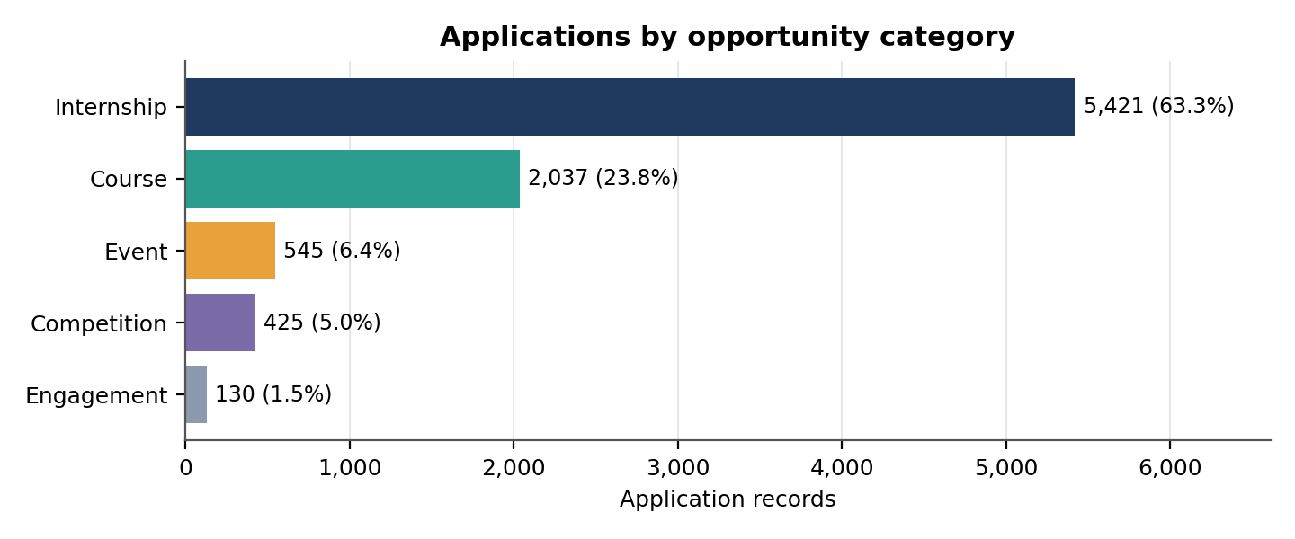
Figure 3: Applications by opportunity category.

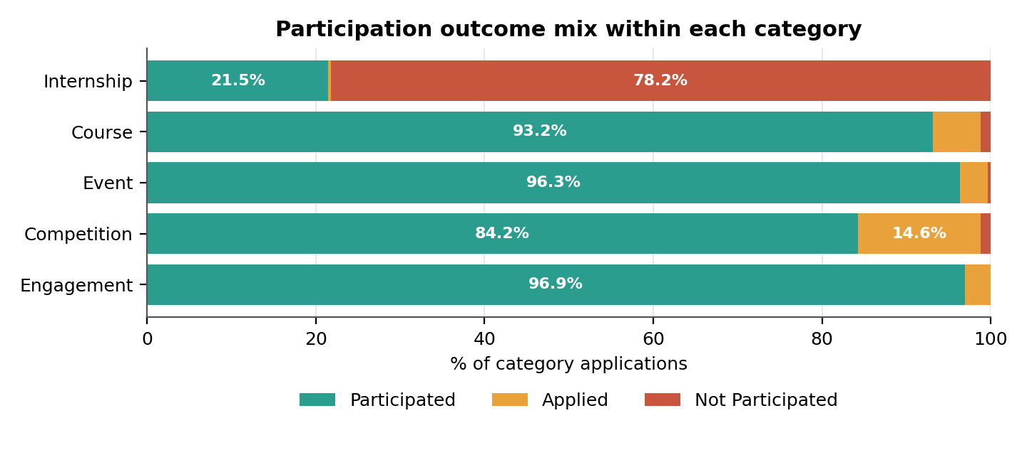
Figure 4: Participation outcome mix within each category.

- Two pipelines: Non-internship categories end almost entirely as Team Allocated or Started (84.2%–96.9%). Internships split three ways: 21.5% allocated, 65.8% rejected and 11.3% dropped out.
- Outcomes sit in single categories: all 3,569 rejections and 613 of the 617 dropouts are internships (the other 4 dropouts are competitions); all 767 Started records are courses. Comparisons across categories are therefore indicative, because status labels appear to be used differently by category.
- Participation distribution: Of the 4,072 participated records, courses supply 46.6% (1,898), internships 28.6% (1,165), events 12.9%, competitions 8.8% and engagement 3.1%. Courses are 23.8% of applications but 46.6% of participation.

Table 5: Applications by category and application quarter (growth pattern)
Quarter | Internship | Course | Event | Competition | Engagement | Total
2022 Q4* | 0 | 43 | 0 | 0 | 0 | 43
2023 Q1 | 0 | 174 | 0 | 4 | 0 | 178
2023 Q2 | 30 | 538 | 24 | 2 | 8 | 602
2023 Q3 | 1,029 | 498 | 68 | 36 | 85 | 1,716
2023 Q4 | 882 | 216 | 79 | 17 | 24 | 1,218
2024 Q1 | 3,472 | 560 | 374 | 366 | 13 | 4,785
2024 Q2* | 8 | 8 | 0 | 0 | 0 | 16
Total | 5,421 | 2,037 | 545 | 425 | 130 | 8,558
* Partial or pre-signup periods.

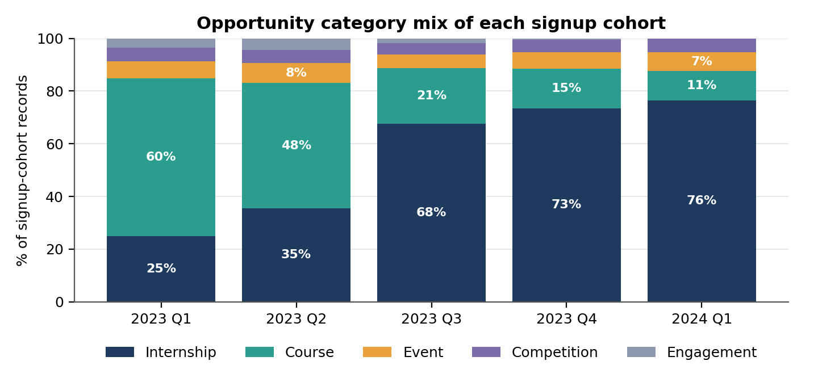
Figure 5: Category mix of each signup cohort. Internships grow from 25% to 76% of signups while courses fall from 60% to 11%.

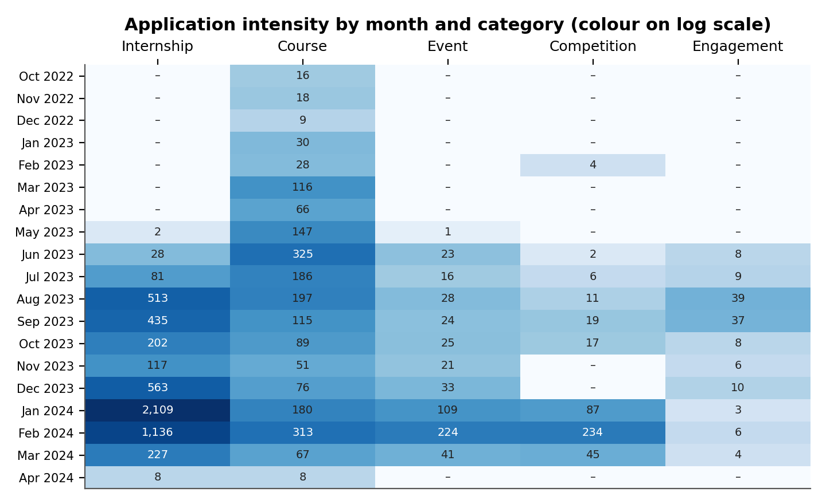
Figure 6: Heatmap of application intensity by month and category.
- Growth patterns: Internship signups grew from 126 (2023 Q1) to 2,106 (2024 Q1), +1,571%. Course signups were the largest group in 2023 Q1 and Q2 (302 and 687) and fell to 309 by 2024 Q1. Engagement signups fell from 62 in 2023 Q2 to 7 in 2023 Q4 and 0 in 2024 Q1, while competition and event signups rose in 2024 Q1 (147 and 193).
- Seasonal behaviour: Each category peaks in a different month: internships in January 2024 (2,109 applications), courses in June 2023 (325), events and competitions in February 2024 (224 and 234) and engagement in August 2023 (39). With one full year of data these are observed peaks, not confirmed seasonality.

3.3 Internship performance by opportunity
Table 6: Internship outcomes by opportunity
Opportunity | Applications | Participation | Rejected | Dropped Out | Other
Data Visualization | 980 | 12.8% | 63.3% | 22.6% | 1.4%
Project Management | 836 | 12.8% | 65.1% | 20.3% | 1.8%
Health Care Management | 784 | 54.8% | 42.1% | 0.0% | 3.1%
Digital Marketing | 559 | 11.4% | 65.5% | 22.7% | 0.4%
Data Visualization Associate | 551 | 22.0% | 77.0% | 0.0% | 1.1%
Business Consulting | 483 | 16.1% | 82.8% | 0.0% | 1.0%
Project Management Associate | 478 | 22.4% | 77.4% | 0.0% | 0.2%
Innovation & Entrepreneurship | 419 | 14.3% | 62.3% | 22.7% | 0.7%
Digital Strategy Virtual Internship | 331 | 22.1% | 76.7% | 0.0% | 1.2%
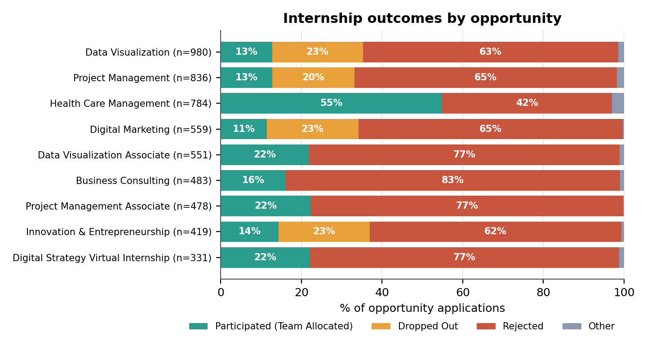
Figure 7: Internship outcomes by opportunity (labels shown for shares of 8% or more).

- Opportunity drives outcome: internship participation ranges from 11.4% (Digital Marketing) to 54.8% (Health Care Management). Health Care Management has 784 applications and no dropouts.
- Four programmes carry the dropouts: Data Visualization, Project Management, Digital Marketing and Innovation & Entrepreneurship make up 51.5% of internship applications and each shows 20.3%–22.7% dropout with 11.4%–14.3% participation. The other five internships have no dropouts.

3.4 Cohort participation analysis
Table 7: Participation by signup-month cohort
Signup month | Records | Participated | Participation rate | Internship share
2023-01 | 230 | 159 | 69.1% | 32.6%
2023-02 | 88 | 64 | 72.7% | 19.3%
2023-03 | 186 | 158 | 84.9% | 18.3%
2023-04 | 281 | 187 | 66.5% | 42.0%
2023-05 | 406 | 284 | 70.0% | 35.0%
2023-06 | 755 | 561 | 74.3% | 33.2%
2023-07 | 713 | 428 | 60.0% | 57.6%
2023-08 | 1,143 | 577 | 50.5% | 69.1%
2023-09 | 683 | 267 | 39.1% | 75.3%
2023-10 | 423 | 210 | 49.6% | 67.1%
2023-11 | 224 | 85 | 37.9% | 74.6%
2023-12 | 659 | 272 | 41.3% | 77.1%
2024-01 | 1,547 | 418 | 27.0% | 86.0%
2024-02 | 1,075 | 363 | 33.8% | 64.0%
2024-03 | 133 | 33 | 24.8% | 66.2%
2024-04 | 12 | 6 | 50.0% | 33.3%
Each row is a cohort of application records, not unique learners; 2024-04 has only 12 records.

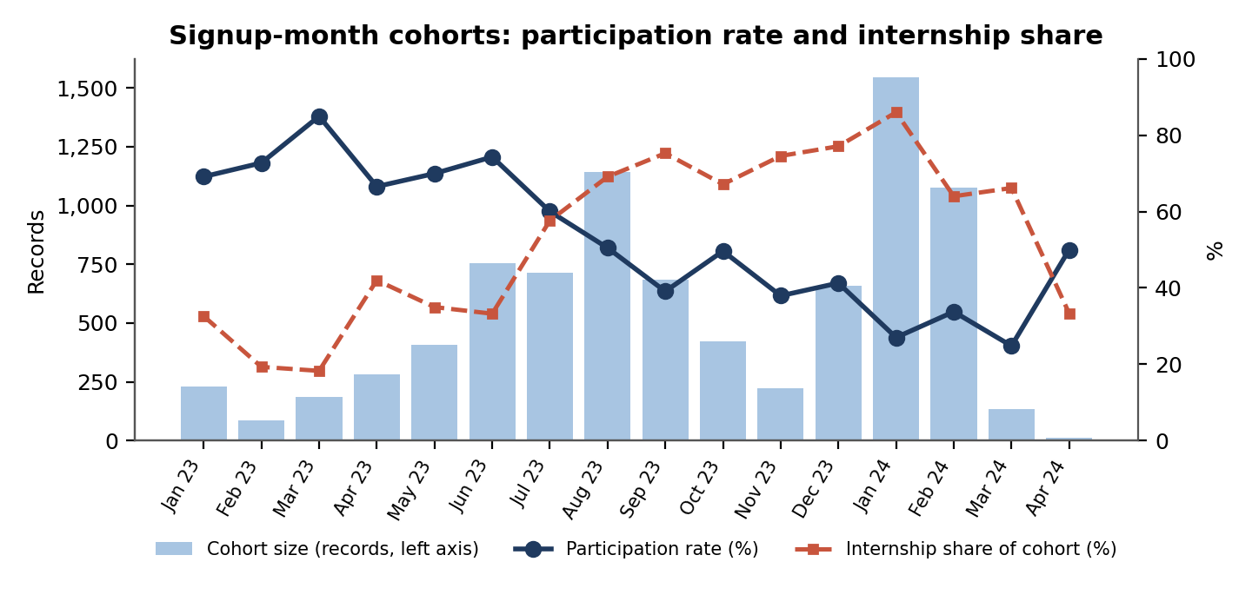
Figure 8: Cohort size, participation rate and internship share by signup month.
Participation is highest for the early 2023 cohorts (60.0%–84.9% for January to July 2023) and falls steadily from July 2023 to 24.8%–33.8% for January to March 2024. The internship share of each cohort rises over the same period, which points to a change in category mix rather than a general loss of engagement.
Table 8: Participation change from the 2023 Q1 to the 2024 Q1 signup cohort, by category
Category | Share 2023 Q1 | Share 2024 Q1 | Participation 2023 Q1 | Participation 2024 Q1 | Mix effect (pp) | Within effect (pp)
Internship | 25.0% | 76.4% | 19.8% | 11.4% | -28.7 | -6.5
Course | 59.9% | 11.2% | 96.7% | 77.3% | -10.3 | -2.2
Event | 6.3% | 7.0% | 93.8% | 97.9% | +0.1 | +0.3
Competition | 5.2% | 5.3% | 69.2% | 99.3% | 0.0 | +1.6
Engagement | 3.6% | 0.0% | 88.9% | No records | -0.5 | 0.0
All categories | 100% | 100% | 75.6% | 29.5% | -39.3 | -6.7
Mix effect = change in category share × (category 2023 Q1 rate − overall 2023 Q1 rate). Within effect = 2024 Q1 share × change in category rate. Rows may not sum exactly because of rounding. The split is descriptive and depends on the weighting chosen; it does not establish cause.
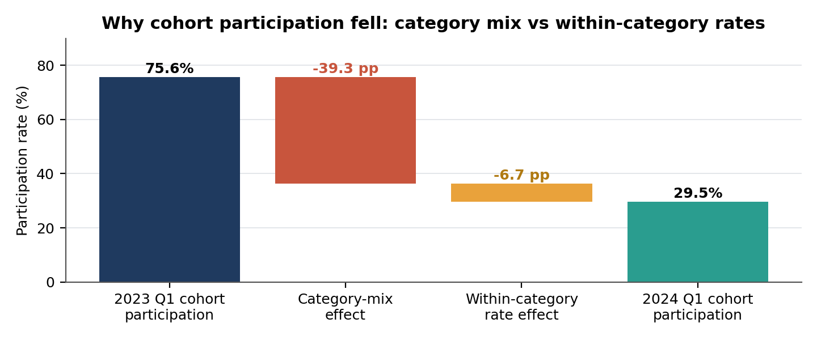
Figure 9: Decomposition of the fall in cohort participation.
- Decomposition: Participation fell 46.0 points (75.6% to 29.5%). Category mix accounts for -39.3 points (85.4%) and lower rates within categories for -6.7 points (14.6%).
- Within-category change: the internship rejection rate rose from 70.6% to 80.6% and course participation fell from 96.7% to 77.3%.

Table 9: Internship participation by opportunity and application quarter (applications in brackets)
Opportunity | 2023 Q3 | 2023 Q4 | 2024 Q1
Health Care Management | 79.2% (313) | 80.7% (207) | 0.0% (247)
Project Management Associate | – | – | 22.2% (459)
Digital Strategy Virtual Internship | – | – | 21.2% (312)
Data Visualization Associate | – | – | 21.8% (522)
Business Consulting | – | – | 14.9% (462)
Innovation & Entrepreneurship | 12.3% (81) | 14.2% (106) | 15.2% (230)
Project Management | 22.1% (231) | 15.5% (161) | 7.0% (442)
Data Visualization | 20.4% (294) | 15.5% (193) | 7.0% (484)
Digital Marketing | 18.1% (105) | 13.9% (137) | 8.0% (314)
All internships excluding Health Care Management | 20.3% (716) | 16.4% (675) | 14.8% (3,225)
All internships | 38.2% (1,029) | 31.5% (882) | 13.7% (3,472)
Cells with fewer than 30 applications are not shown.
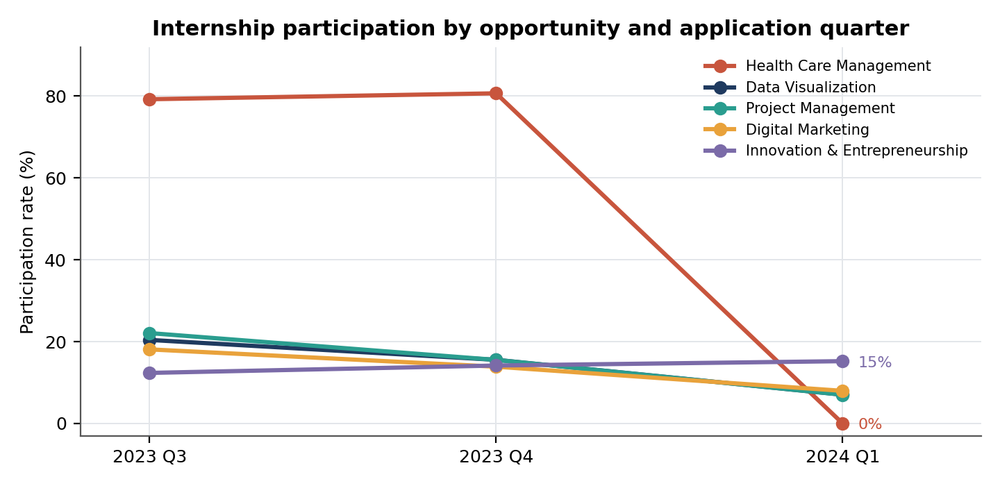
Figure 10: Participation by internship opportunity and application quarter.
- Health Care Management stops allocating: participation was 79.2% in 2023 Q3 and 80.7% in 2023 Q4. From February 2024 none of its 249 applications was allocated (245 rejected, 4 still Applied), and January 2024 has no applications. This explains most of the fall in internship participation to 13.7% in 2024 Q1; excluding it, internship participation moves from 20.3% to 14.8%.
- Other opportunities: Data Visualization (20.4% to 7.0%), Project Management (22.1% to 7.0%) and Digital Marketing (18.1% to 8.0%) decline each quarter, while Innovation & Entrepreneurship stays flat (12.3% to 15.2%). Four programmes appear mainly from 2024 Q1 and participate at about 15%–22%.

3.5 Engagement consistency
The dataset has no learner ID, so repeat behaviour per learner cannot be tracked. Consistency is therefore measured with cohort-level proxies: the time from signup to application, cohort stability, and each opportunity’s stability across quarters (Tables 10 and 11).

Table 10: Time from signup to application (% of each category’s applications)
Category | Applications | Same day | 1–7 days | 8–30 days | 31–90 days | 90+ days
Internship | 5,385 | 40.5% | 15.5% | 8.7% | 9.5% | 25.7%
Course | 1,980 | 41.4% | 16.2% | 13.3% | 13.3% | 15.9%
Event | 541 | 27.7% | 11.6% | 9.6% | 14.4% | 36.6%
Competition | 420 | 19.5% | 10.7% | 11.2% | 13.1% | 45.5%
Engagement | 129 | 1.6% | 5.4% | 11.6% | 31.8% | 49.6%
All categories | 8,455 | 38.3% | 15.0% | 10.0% | 11.2% | 25.5%
Excludes the 103 apply-before-signup records. Lag = Apply Date − Signup Date.

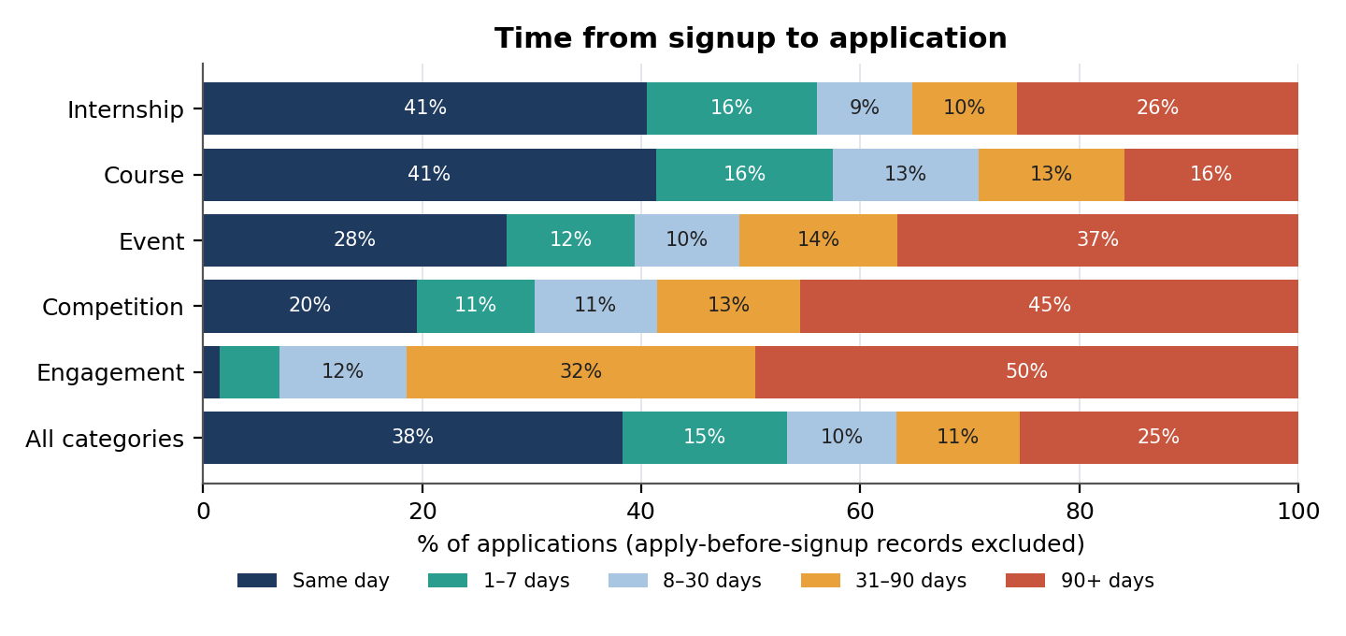
Figure 11: Time from signup to application by category.
- Timing: 38.3% of applications arrive on the signup day and 25.5% arrive 90 or more days later. Course (41.4% same day) and internship (40.5%) learners apply fastest; engagement (49.6% at 90+ days) and competition (45.5%) learners apply latest.
- Weak signal: internship participation is 24.1% for same-day applicants and 18.7% to 21.8% for later groups, so lag adds little on its own.

Table 11: Cohort consistency by signup quarter
Signup quarter | Records | Applied same day | Median lag (days) | Applied 90+ days later | Participation (all) | Participation (internships) | Internship dropout
2023 Q1 | 504 | 21.7% | 162 | 55.7% | 75.6% | 19.8% | 7.9%
2023 Q2 | 1,442 | 25.0% | 84.5 | 49.0% | 71.6% | 26.2% | 11.9%
2023 Q3 | 2,539 | 30.3% | 35 | 41.2% | 50.1% | 30.3% | 9.3%
2023 Q4 | 1,306 | 35.8% | 10.5 | 11.8% | 43.4% | 25.7% | 24.8%
2024 Q1 | 2,755 | 56.5% | 0 | 0.0% | 29.5% | 11.4% | 6.8%
Lag columns exclude apply-before-signup records and run low for later cohorts, which have had less time to apply. 2024 Q2 (12 records) is omitted.
- December 2023 cohort: internship dropout reaches 24.8%, against 6.8%–11.9% in every other signup quarter. The December 2023 signup cohort holds 188 dropouts (28.5% of the cohort): Data Visualization 73, Project Management 48, Digital Marketing 42 and Innovation & Entrepreneurship 25.

3.6 Learner profile signals
Table 12: Participation by country, raw and adjusted for category mix
Country | Applications | Raw participation | Internship share | Internship-only participation | Mix-adjusted participation
United States | 3,976 | 40.0% | 70.4% | 18.3% | 45.2%
India | 2,836 | 49.4% | 61.8% | 23.0% | 48.3%
Nigeria | 760 | 57.1% | 57.5% | 29.7% | 50.9%
Ghana | 275 | 61.8% | 48.0% | 27.3% | 51.6%
Pakistan | 219 | 71.2% | 35.2% | 23.4% | 48.6%
Mix-adjusted = within-category rates re-weighted to the overall category mix. The five countries with 200+ applications are shown (70 countries in total).
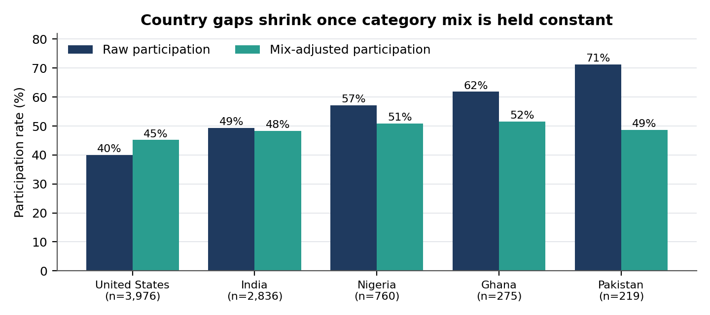
Figure 12: Raw and mix-adjusted participation by country.
- Category mix explains most country gaps: raw participation runs from 40.0% (United States) to 71.2% (Pakistan), but only 35.2% of Pakistan’s applications are internships against 70.4% for the United States. Adjusted rates fall between 45.2% and 51.6%. On internships alone the United States is lowest (18.3%) and Nigeria highest (29.7%).

Table 13: Saint Louis University (SLU) versus other institutions
Institution group | Applications | Participation | Internship share | Internship-only participation
SLU (name variants merged) | 4,503 | 41.3% | 69.3% | 18.5%
All other institutions | 4,055 | 54.5% | 56.7% | 25.5%
SLU spelling variants are merged by text match, so the group is approximate.

- SLU is the largest and fastest-growing group: it makes up 52.6% of records and rises from 27.8% of 2023 Q1 signups to 62.6% of 2024 Q1 signups, which contributes to the shift towards internships. SLU participates less (41.3% against 54.5%, and 18.5% against 25.5% within internships). Weighting both groups to the same internship opportunity mix gives 17.8% against 25.8%, so the gap persists.

Table 14: Other learner signals
Signal | Group | Records | Participation
Age group (internships only) | Under 18 | 171 | 53.2%
 | 18–24 | 3,726 | 19.5%
 | 25–34 | 1,387 | 22.3%
 | 35+ | 137 | 27.7%
Gender (internships only) | Female | 2,209 | 23.0%
 | Male | 3,208 | 20.5%
Application day (all categories) | Weekday | 6,541 | 47.6%
 | Weekend | 2,017 | 47.4%
Under-18 internship applicants show higher participation but rest on only 171 records. Gender and weekend differences are small.

3.7 Unusual patterns and anomalies
Table 15: Anomalies, likely type and treatment
Pattern | Finding | Type | Treatment
Apply date before signup | 103 records, 43 of them dated 2022 Q4, before the first signup on 5 Jan 2023 | Data error | Flag; exclude from signup-to-application metrics, quarter ranking and growth
Signup spikes | 5 Jan 2023 (146), 9 Jul 2023 (141) and 16 Jun 2023 (118), against an average of 20.7 per signup day (median 13) | Likely real | Keep; drill down by opportunity; test results with and without these days
December 2023 dropouts | 188 dropouts in the December 2023 signup cohort, concentrated in four internships | Possibly real | Keep; add a cohort feature in Week 3
Health Care Management | 249 applications from February 2024 with none allocated (about 80% allocated before) | Possibly real | Add an opportunity-level feature in Week 3
Engagement fades | 62 signups in 2023 Q2 fall to 0 in 2024 Q1 | Likely real | Report; exclude from growth comparisons
Start date after end date | 116 records with negative opportunity duration | Data error | Verify before any duration analysis
Applied after start date | 2,106 records with negative lead time; 1,878 are courses, 138 competitions, 78 engagement, 10 internships | Likely real | Keep; use Already_Started flag
Age under 14 | 31 records (30 aged 13, 1 aged 3) | Data error (to be confirmed) | Keep flagged; confirm against programme age rules
AI Ethics Challenge and Slide Geeks | All 55 AI Ethics Challenge records are Applied; all 4 Slide Geeks records are Dropped Out | Unusual | Check status handling for these two opportunities

4. Interpretation of Findings

4.1 Factors that most strongly influence participation
Table 16: Ranking of factors by observed strength
# | Factor | Strength | Evidence
1 | Opportunity category | Strong | Participation 21.5% for internships against 84.2%–96.9% elsewhere
2 | Specific opportunity (within internships) | Strong | Internship participation ranges from 11.4% to 54.8%; four programmes carry the dropouts. Strong historically, but unstable over time (see Section 6.4).
3 | Application and signup period | Moderate | Cohort participation falls from 75.6% to 29.5%, mostly through category mix (about 85%)
4 | Institution group (SLU or other) | Moderate | 41.3% against 54.5% overall; 17.8% against 25.8% on a standardised internship mix
5 | Signup-to-application lag | Weak | Internship participation stays between 18.7% and 24.1% across lag groups
6 | Country, gender, age group, weekend | Weak or unclear | Country gaps shrink once category mix is held constant; age and gender differences are small or rest on small groups

4.2 Early signals of high and low engagement
- High: event, engagement, course and competition applications (84%–97% participation), and Health Care Management before February 2024 (about 80%).
- Low: Data Visualization, Project Management, Digital Marketing and Innovation & Entrepreneurship (11%–14% participation, 20%–23% dropout), and any internship application made in 2024 Q1 (13.7% participation).
- Drift: a sharp drop in an opportunity’s allocation rate between quarters signals a rule or capacity change rather than weaker learners.

4.3 Forecasting signals
- Strong seasonal indicators observed: application peaks in August 2023 (788) and January–February 2024 (2,488 and 1,913), a December 2023 rise in dropouts, and signup spikes on 5 Jan 2023, 16 Jun 2023 and 9 Jul 2023. With one full year of history, none of these can be confirmed as recurring seasonality.
- Variables likely to influence predictions: opportunity category, opportunity identity (strong historically but unstable over time; see Section 6.4), application quarter, signup cohort, institution group and signup-to-application lag.
- Observations for modelling: demand shifted structurally towards internships in 2024, so quarter-level volume is partly a category-mix effect; outcome behaviour changes by opportunity over time (Health Care Management); and engagement signups have stopped.

5. Preparation for Modelling
The cleaned dataset holds 8,558 application records with clear status labels and 20 derived features. It supports exploratory predictive modelling under the conditions below.
Table 17: Data-quality conditions for modelling
Check | Result | Action
Unit of analysis | Rows are application records, not unique learners | State this in all model documentation
Learner identifier | Not supplied | Request a stable learner ID and dated activity history to measure retention
Target definition | Participated = Started, Team Allocated or Rewards Award | Decide how to label the 214 Waitlisted and Applied records
Target leakage | Status Description, Status Code, Participated and outcome-derived fields | Exclude from predictors for an at-application forecast
Missing lead time | 3,794 records have no Opportunity Start Date | Keep missing; report denominators; consider a missingness indicator
Cohort dates | Signup date defines cohorts; Apply Date defines application trends | Keep the two separate
Date anomalies | 103 apply-before-signup and 116 start-after-end records | Exclude from time-interval features or flag

Features and patterns useful for machine learning
- Strongest: opportunity category and, within internships, the specific opportunity (strong historically, but unstable over time; see Section 6.4).
- Moderate: institution group, signup and application quarter, and signup-to-application lag.
- Weak or unclear: country (mostly a category-mix effect), gender, age group (small counts) and weekend application.
- Evaluation design: split by time (train on earlier quarters, test on later ones), because participation shifts sharply by period and Health Care Management changes its allocation behaviour in 2024. Compare within-category rates as well as raw counts, because categories differ greatly in volume.

6. Baseline Forecasting and Model Evaluation (Indicative Only)
Reliability warning
The dataset holds five valid quarters (2023 Q1 to 2024 Q1), and only 2023 is a full year. That is too little history to train or validate a dependable forecast or model. The results in this section are simple baselines that show direction and set a benchmark for Week 3. They must not be used for planning, targets or decisions.

6.1 Forecasting approach
Four deliberately simple methods were applied to quarterly application counts: the last quarter’s value, the average of all earlier quarters, the average of the last two quarters, and a straight-line trend. Each was tested by a one-step-ahead backtest: forecast a quarter from the quarters before it, then compare with the actual value. Seasonal methods were not used because they need at least two full years of history.

6.2 Quarterly demand forecast
Table 18: Backtest of quarterly application forecasts (percentage error in brackets)
Quarter forecast | Actual | Last quarter | Average of all earlier | Average of last two | Straight-line trend
2023 Q3 | 1,716 | 602 (65%) | 390 (77%) | 390 (77%) | 1,026 (40%)
2023 Q4 | 1,218 | 1,716 (41%) | 832 (32%) | 1,159 (5%) | 2,370 (95%)
2024 Q1 | 4,785 | 1,218 (75%) | 929 (81%) | 1,467 (69%) | 1,987 (58%)
Mean absolute % error |  | 60.1% | 63.2% | 50.5% | 64.4%
Every method misses by 40% to 95% in at least one test quarter, and the best average error is about 50%.
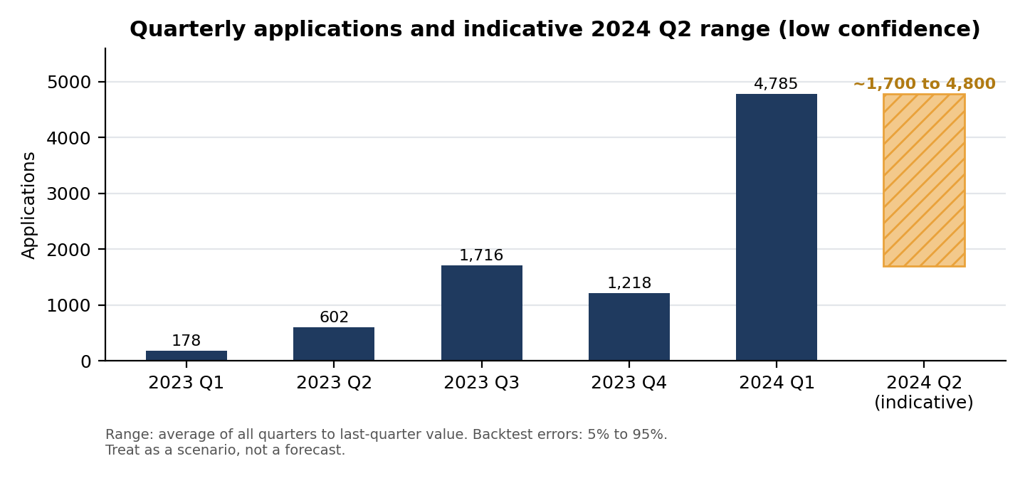
Figure 13: Quarterly applications and the indicative 2024 Q2 range.
- Indicative 2024 Q2 range: from about 1,700 (average of all earlier quarters) to 4,785 (last quarter), with 3,002 from the two-quarter average and 4,649 from the trend line. The range is wide because the methods disagree and none is reliable. It cannot be checked yet: the data holds only 16 applications for 2024 Q2, up to 10 April 2024.
- Direction: the 2024 Q1 surge is driven by internships (72.6% of that quarter), so any level forecast depends mainly on whether internship intake continues.

6.3 Opportunity category forecast
Table 19: Applications by category and indicative 2024 Q2 range
Category | 2023 Q4 | 2024 Q1 | Indicative 2024 Q2 range | Latest participation rate
Internship | 882 | 3,472 | 2,177 to 3,472 | 11.4% (2024 Q1 cohort)
Course | 216 | 560 | 388 to 560 | 77.3% (2024 Q1 cohort)
Event | 79 | 374 | 227 to 374 | 97.9% (2024 Q1 cohort)
Competition | 17 | 366 | 192 to 366 | 99.3% (2024 Q1 cohort)
Engagement | 24 | 13 | 13 to 19 | No 2024 Q1 signups
Range = average of the last two quarters to the last quarter’s value. Participation rates are from the 2024 Q1 signup cohort (Table 8); the Engagement figure refers to its signups.
- Reading the table: internships are expected to stay the largest category but with a participation rate near 11% for the 2024 Q1 signup cohort (13.7% by application quarter). Courses, events and competitions keep high participation rates, and engagement activity has faded. These are simple extensions of the last two quarters, not predictions.

6.4 Baseline participation model
A first model was built to predict whether an application ends as Participated or Not Participated. The 214 Applied records were excluded, leaving 8,344 records. The data was split by time: 3,702 applications dated before 2024 for training and 4,642 dated 2024 onward for testing. Participation was 65.4% in the training period and 35.6% in the test period, so the test period behaves very differently. Predictors were limited to information known at application: category, opportunity name, country group, gender, age group, age, Saint Louis University flag, signup-to-application lag and weekend application. Status fields were excluded to avoid leakage. “Participated” is the positive class.
Table 20: Model evaluation on the 2024 test period
Model | Accuracy | Precision | Recall | F1 score | ROC-AUC
Majority-class baseline | 35.6% | 35.6% | 100.0% | 0.525 | 0.500
Category-rate rule | 82.0% | 100.0% | 49.5% | 0.662 | 0.639
Logistic regression | 79.8% | 73.8% | 67.3% | 0.704 | 0.845
Random forest | 84.3% | 81.1% | 72.8% | 0.767 | 0.867
The majority-class baseline predicts every application as Participated (the majority class in training). The category-rate rule predicts Participated for any category whose training participation rate was above 50%.
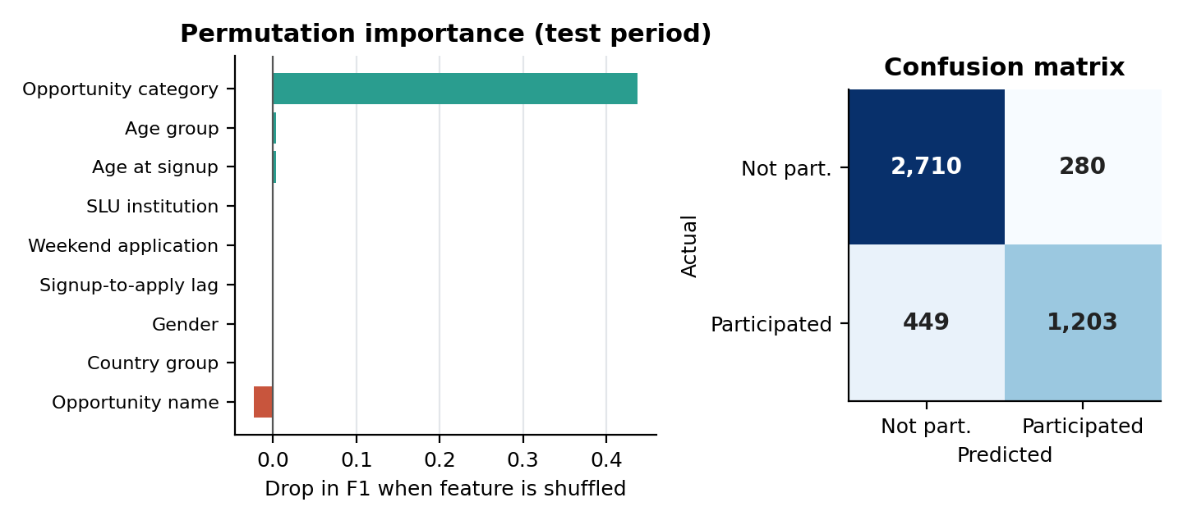
Figure 14: Permutation feature importance (change in F1) and confusion matrix for the random forest.
- Result: the random forest scores best (F1 0.767, accuracy 84.3%), ahead of logistic regression (F1 0.704) and the benchmarks.
- Feature importance: opportunity category is the only feature with a clear effect (F1 falls by 0.44 when it is shuffled); every other feature is within ±0.004 of zero. Opportunity name has a negative value (-0.023), meaning it hurts predictions in the later period.
- Within internships the model has almost no skill: on the 3,465 internship applications in the test period, F1 is 0.069 (precision 8.8%, recall 5.7%). The headline score comes mainly from separating internships from the other categories.
- Regime change: all 245 Health Care Management applications in the test period were predicted as Participated because it allocated about 80% of applicants before 2024; none were allocated. Excluding that opportunity, accuracy is 89.0% and F1 is 0.833.
- Validation method matters: a random 5-fold split gives F1 0.864, higher than the 0.767 from the time-based split, so random splitting overstates how well the model would perform on future applications.

6.5 Implications for Week 3
- Benchmark: overall F1 of 0.767 (random forest) and 0.662 for the category-rate rule; a Week 3 model should beat the internship-only result (F1 0.069) to add value beyond category.
- Data needs: more history (at least two full years for seasonal methods), a learner identifier, confirmed status definitions, and dates showing when each outcome occurred.
- Modelling advice: evaluate by time, report results by category and by opportunity, and track opportunity-level allocation rules as features or monitoring flags.

7. AI-Assisted Analysis
Table 21: AI use, validation and results
Section | AI tool | Use | Validation
Refining the Compiled and Finalized Report | Claude | Compiled this report from the team’s Week 2 outputs and the cleaned dataset; generated Figures 1 to 14, including the baseline forecasts and participation models in Section 6 (Python, scikit-learn); reconciled differences between member outputs | Every figure recomputed from the Week2 Cleaned Data sheet with Python (pandas); where a team figure differed, the recomputed value was used
Section 3 (tables and findings) | Claude | Recalculated the quarterly, category, cohort, consistency and learner-profile tables | Recomputed values were compared with the analysis workbooks; the recomputed value is reported
Cohort participation report, SQL and Looker Studio workflow | AI assistant, as documented by Kamoru | Structured the report, suggested visualisations and drafted SQL and Looker Studio guidance | Counts and charts in the member’s report checked against the cleaned dataset; all matched
Quarterly, category and cohort analysis (Barira Khan’s analysis sheet); unusual patterns (Section 3.7) | Claude | Converted the member’s calculated analysis sheet into a report; helped identify unusual patterns | Calculations come from the member’s analysis workbook; figures checked against the cleaned dataset in this report
Cohort, consistency and learner-profile analysis (Rophiat’s updated analysis workbook) | Claude | Updated the report to reflect the member’s changes and additions to the Excel sheets | Calculations come from the member’s workbook; figures checked against the cleaned dataset in this report
Dashboard report (Nour Ahmed’s Power BI dashboard) | AI assistant, as documented by Nour | The member built the dashboard herself; AI was used to write the report from it | Dashboard output reviewed against the cleaned dataset; record-level figures recomputed for this report
Visualisation report and Streamlit dashboard (Khadija Kamal) | ChatGPT | Helped with the Python code and setting up the interactive Streamlit dashboard | Dashboard totals (8,558 records; 4,072 / 4,272 / 214 participation labels) match the cleaned dataset

Ghufran Khan and Victor Thompson (cleaned dataset and feature engineering) did not use AI.

Validation notes
- Counting basis: all counts are application records. Distinct-learner counts are not available because the dataset has no learner ID, so category shares are record shares (Internship 63.3%, Course 23.8%).
- Lead time: lead-time counts are reported for the 4,764 records with an Opportunity Start Date: 2,106 negative, 17 zero and 2,641 positive. The 3,794 records without a start date are blank, not zero.
- Cohort decomposition: the split of 85.4% category mix and 14.6% within-category rates uses 2023 Q1 category rates as the baseline (Table 8). A different weighting changes the split but not the conclusion that category mix is the main driver.
- Saint Louis University: 4,503 records (52.6%) with spelling variants merged, consistent with the Week 1 report.
- Feature basis: Signup_* features derive from Learner Signup Date and Application_* features from Apply Date.

8. Limitations
- Records are not learners: no learner ID exists, so unique-participant and repeat-behaviour metrics cannot be calculated.
- Status meaning: the Participated label groups statuses for analysis; status labels appear to be used differently by category, so cross-category comparisons are indicative.
- Coverage: one full year (2023) and two partial quarters; 2022 Q4 and 2024 Q2 are excluded from rankings.
- Date correction: the Week 1 day/month correction is an inference from the data and has not been confirmed by the data owner.
- Forecasting: five valid quarters are too few to forecast or model reliably; Section 6 results are baselines only.
- Descriptive analysis: differences reported here describe the data and do not establish causes.

